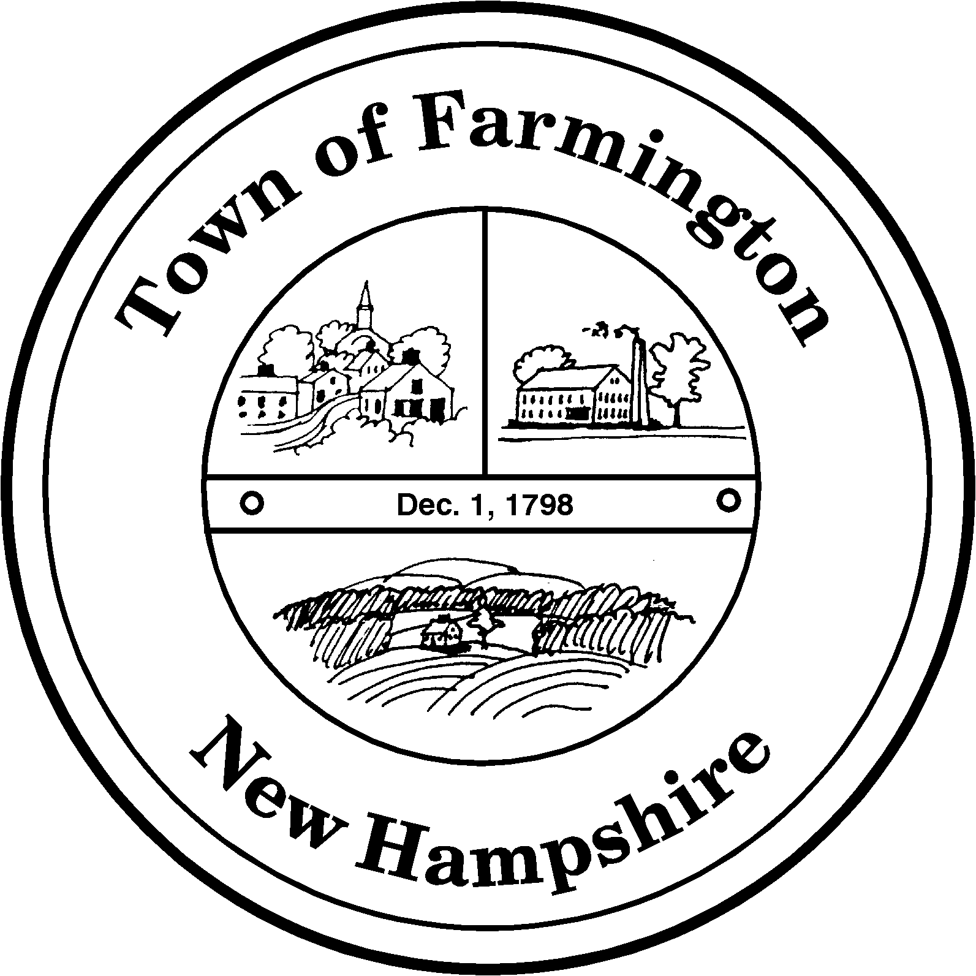
Town of Farmington
Planning and Community Development
356 Main Street
Farmington, NH 03835
Phone: (603) 755-2774
A Bicentennial Community
1798 - 1998

PLANNING BOARD MEETING

TUESDAY – August 16, 2011

356 Main Street - Farmington, NH

AGENDA - 6:00 p. m.

BUSINESS BEFORE THE BOARD:

- Pledge of Allegiance

- Review and approve Meeting Minutes of August 2, 2011

- Any other business to come before the board.

PUBLIC HEARING 6:30 P.M.

CONTINUED CASES:

- Application for Major Site Plan Approval By: David J. Haycock (Tax Map R-47, Lot 5) for property located at 96 Bunker Street to allow the operation of a logging company as a home business. The proposal includes locating storage trailers on the property, construction of a pole barn, and on-site equipment and vehicle storage. The parcel is located in the Urban Residential (UR) Zoning District. Continued from June 21, 2011.

NEW CASES:

- Application for a Boundary Line Adjustment by Glenn and Catherine Costanzo (Tax Map U-3 Lot 15-1) and Karen Cameron (Tax Map U-3 Lot 15-2): To annex 6,139 sq. ft. from Map U-3 Lot 15-2 to U-3 Lot 15-1. The parcels are located at 13 and 14 Beechwood Dr., and are in the Commercial Business district.

- Application for Excavation Permit by: Pike Industries, Applicant, and Thomas and Michelle Huckins, Owners, (Tax Map R15, Lot 14) for property located off NH Route 11. The parcel is located in Rural Residential (RR) Zoning District.

- Application for Excavation Permit by Pike Industries (Tax Map R35 Lot 7) for property located on Paulson Road. The parcel is located in the Suburban Residential (SR) Zoning District.

Paul Parker, Chairman,

Farmington Planning Board

